 



DHAKA Thursday NOVEMBER 28, 2024

Reg No: DA201 Vat. XZX#245 [www.thedailystar.net](http://www.thedailystar.net) Jumada Al-Awwal 16,1446 Ogrohayon 4,1431 16 P Max: TK 15.00

# Dhaka reaffirms equal respect for all faiths

# Foreign Adviser Touhid Hossain has reaffirmed Bangladesh's commitment to safeguarding religious sites and fostering interfaith harmony. Speaking at the UN Global Conference on "Safeguarding Religious Sites: A Multi-Stakeholder Approach" in Portugal today, Hossain highlighted acts of unity, citing the recent efforts of young Muslim students who protected Hindu temples during a major festival, exemplifying the spirit of peaceful coexistence.

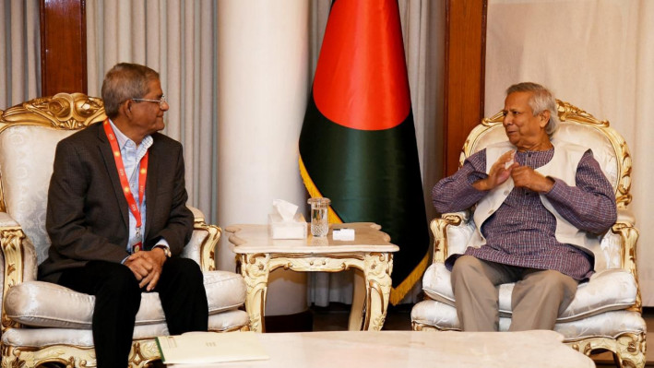

# Build national unity to tackle ongoing challenges: BNP

BNP Secretary General Mirza Fakhrul Islam Alamgir today urged the interim government to hold discussions with all political parties to build national unity for tackling ongoing challenges. "We hope the chief adviser will promptly arrange a peaceful solution. The country should not be reach a situation that leads to division. At this moment, what is most needed is national unity, which we have conveyed to him," Fakhrul told reporters in front of the State Guest House Jamuna.

# Global security hotspots awaiting Trump in 2025

# **The coming year will put incoming US President Donald Trump's geopolitical strategies to the test, as wars rage in the Middle East and Ukraine and tensions rise in Asia.**



# Hong Kong jails 45 democracy activists in landmark national security trial

Hong Kong's High Court on Tuesday sentenced 45 pro-democracy activists to jail terms of up to 10 years in a landmark national security trial that has damaged the city's once feisty democracy movement and drawn international **condemnation.**

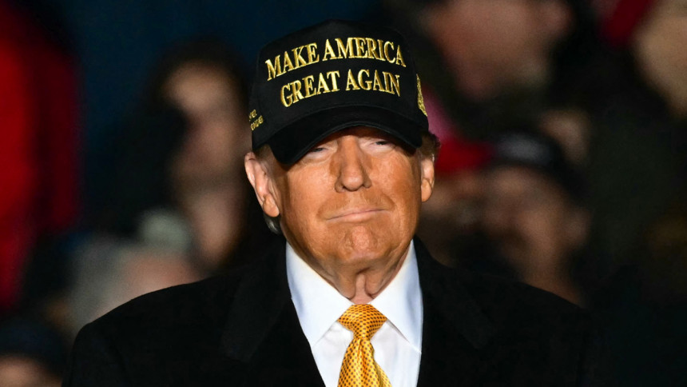

# ACC starts probe on ex-MP Shahin

The Anti-Corruption Commission (ACC) started an investigation against former lawmaker and Jashore district Awami League General Secretary Shahin Chakladar.

16 Days of Activism

# Bridging evidence gaps to end gender-based violence

# **A Dhaka court today placed former food minister Qamrul Islam on an eight-day remand in a murder case filed over the death of trader Abdul Wadud during quota reform protests in Dhaka's New Market area on July 19.**

# Importers hit by dollar crisis get 8 years to repay loans

Businessmen involved in import-dependent industries that have suffered losses due to the depreciation of the local currency against the US dollar will get up to eight years to repay their loans.

